Programming Assignment Unit 5

University of the People

CS 2203 Databases 1

Naeem Ahmed, instructor

October 05, 2022

Programming Assignment Unit 5

For this week’s Programming Assignment, we have to create SQL DLL statements to implement the database schema in MySQL, IBM DB2, SQL Server…

As for me, I use MySQL as can be seen in the screenshots below.

Below is the E-R diagram I defined and normalized as part of Unit 4 Programming Assignment.

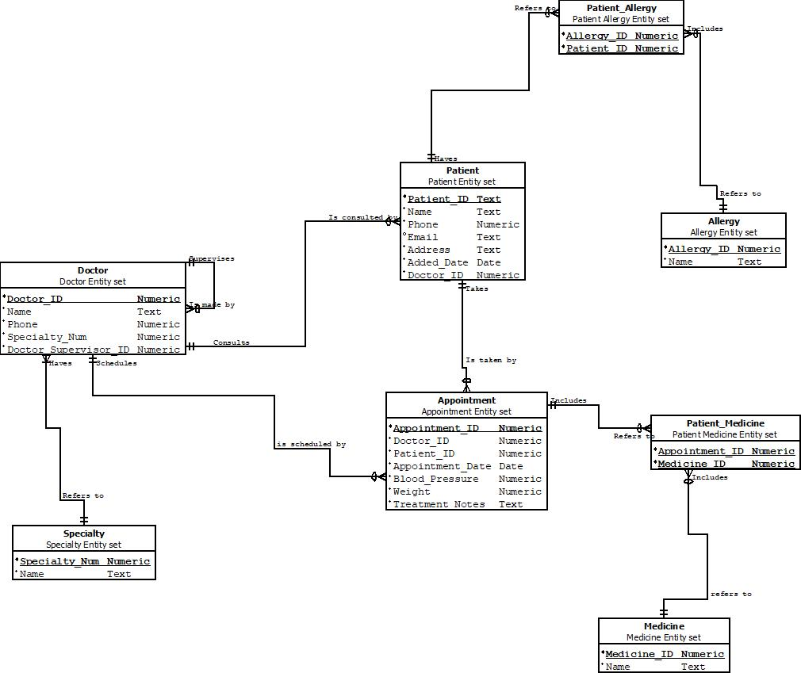

As required the assignment, it must include the SQL DDL statements required to implement at least the following relations:  
- Doctor  
- Patient  
- Appointment  
- Specialty  
- PatientMedicine  
- Medicine  
- PatientAllergy  
- Allergy

Therefore, let us create the tables for the database.

/* Create Doctor table */

CREATE TABLE DOCTOR(

Doctor_ID CHAR(10) NOT NULL,

Name VARCHAR(30) NOT NULL,

Phone CHAR(25) NOT NULL,

Specialty_Num CHAR(10) NOT NULL,

Supervisor_ID CHAR(10) NOT NULL,

CONSTRAINT PK_DR PRIMARY KEY (Doctor_ID),

CONSTRAINT UQ_DR UNIQUE (Doctor_ID),

CONSTRAINT FK_SPLTY FOREIGN KEY (Specialty_Num)

REFERENCES SPECIALTY(Specialty_Num)

);

/* Create Patient table */

CREATE TABLE PATIENT(

Patient_ID CHAR(10) NOT NULL,

Name VARCHAR(30) NOT NULL,

Phone CHAR(25) NOT NULL,

Email CHAR(50),

Address CHAR(120) NOT NULL,

Added_Date DATE NOT NULL,

Doctor_ID CHAR(10) NOT NULL,

CONSTRAINT PK_PATNT PRIMARY KEY (Patient_ID),

CONSTRAINT UQ_PATNT UNIQUE (Patient_ID),

CONSTRAINT FK_D FOREIGN KEY (Doctor_ID) REFERENCES DOCTOR(Doctor_ID)

);

/* Create Appointment table */

CREATE TABLE APPOINTMENT(

Appointment_ID CHAR(10) NOT NULL,

Patient_ID CHAR(10) NOT NULL,

Doctor_ID CHAR(10) NOT NULL,

Appointment_Date DATE NOT NULL,

Blood_Pressure INT NOT NULL,

Weight DECIMAL(5, 2) NOT NULL,

Treatment_Notes CHAR(230) NOT NULL,

CONSTRAINT PK_APP PRIMARY KEY (Appointment_ID),

CONSTRAINT UQ_APP UNIQUE (Appointment_ID),

CONSTRAINT FK_D_APP FOREIGN KEY (Doctor_ID) REFERENCES DOCTOR(Doctor_ID),

CONSTRAINT FK_PATNT_APP FOREIGN KEY (Patient_ID) REFERENCES PATIENT(Patient_ID)

);

/* Create Specialty table */

CREATE TABLE SPECIALTY(

Specialty_Num CHAR(10) NOT NULL,

NAME VARCHAR(30),

CONSTRAINT PK_SPLTY_N PRIMARY KEY (Specialty_Num),

CONSTRAINT UQ_SPLTY_N UNIQUE (Specialty_Num)

);

/* Create Patient_Medicine table */

CREATE TABLE PATIENT_MEDICINE(

Appointment_ID CHAR(10) NOT NULL,

Medicine_ID CHAR(10) NOT NULL,

CONSTRAINT PK_APP_M PRIMARY KEY (Appointment_ID, Medicine_ID),

CONSTRAINT UQ_APP_M UNIQUE (Appointment_ID, Medicine_ID),

CONSTRAINT FK_APP FOREIGN KEY (Appointment_ID) REFERENCES APPOINTMENT(Appointment_ID),

CONSTRAINT FK_M FOREIGN KEY (Medicine_ID) REFERENCES MEDICINE(Medicine_ID)

);

/* Create Medicine table */

CREATE TABLE MEDICINE(

Medicine_ID CHAR(10) NOT NULL,

Name VARCHAR (50) NOT NULL,

CONSTRAINT PK_M PRIMARY KEY (Medicine_ID),

CONSTRAINT UQ_M UNIQUE (Medicine_ID)

);

/* Create Patient_Allergy table */

CREATE TABLE PATIENT_ALLERGY(

Allergy_ID CHAR(10) NOT NULL,

Patient_ID CHAR(10) NOT NULL,

CONSTRAINT PK_A_PATNT PRIMARY KEY (Allergy_ID, Patient_ID),

CONSTRAINT UQ_A_PATNT UNIQUE (Allergy_ID, Patient_ID),

CONSTRAINT FK_A FOREIGN KEY (Allergy_ID) REFERENCES ALLERGY(Allergy_ID),

CONSTRAINT FK_PATNT FOREIGN KEY (Patient_ID) REFERENCES PATIENT(Patient_ID)

);

/* Create Allergy table */

CREATE TABLE ALLERGY(

Allergy_ID CHAR(10) NOT NULL,

Name VARCHAR(35) NOT NULL,

CONSTRAINT PK_A PRIMARY KEY (Allergy_ID),

CONSTRAINT UQ_A UNIQUE (Allergy_ID)

);

**Pictures**

The different tables in the database.

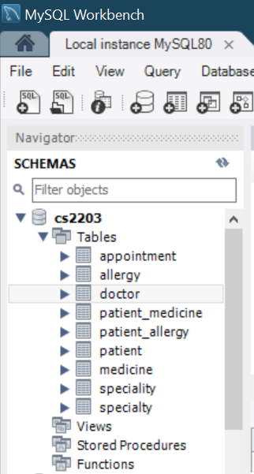

SELECT * FROM SPECIALTY;

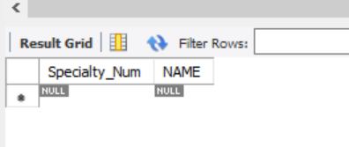

SELECT * FROM DOCTOR;

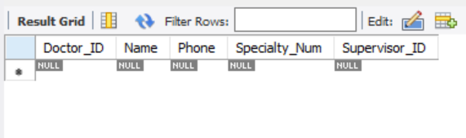

SELECT * FROM PATIENT;

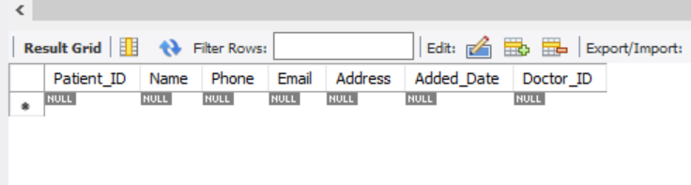

SELECT * FROM ALLERGY;

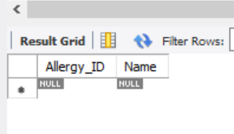

SELECT * FROM PATIENT_ALLERGY;

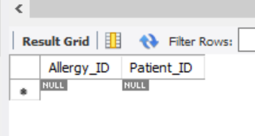

SELECT * FROM APPOINTMENT;

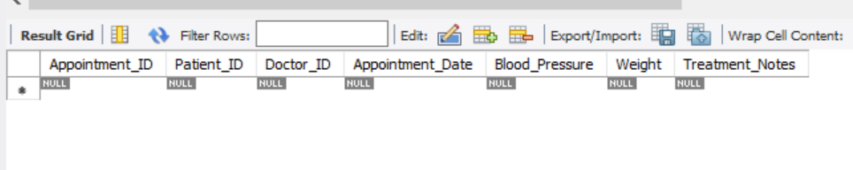

SELECT * FROM MEDICINE;

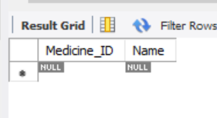

SELECT * FROM PATIENT_MEDICINE;

